**PSUC Lab Assignment**

**Lab:3**

**Q1**) Reverse a given number and check if it is a palindrome or not. (use while loop).

**Code**:

#include<stdio.h>

int main()

{

int num,copy,sum=0,rev;

printf("Enter the number\n",&num);

scanf("%d",&num);

copy=num;

while(num!=0)

{

rev=num%10;

sum=sum*10+rev;

num = num/10;

}

if (sum==copy)

printf("the number %d is a palindrome\n",copy);

else

printf("the number %d is not a palindrome\n",copy);

printf("My name is Saksham\n");

return 0;

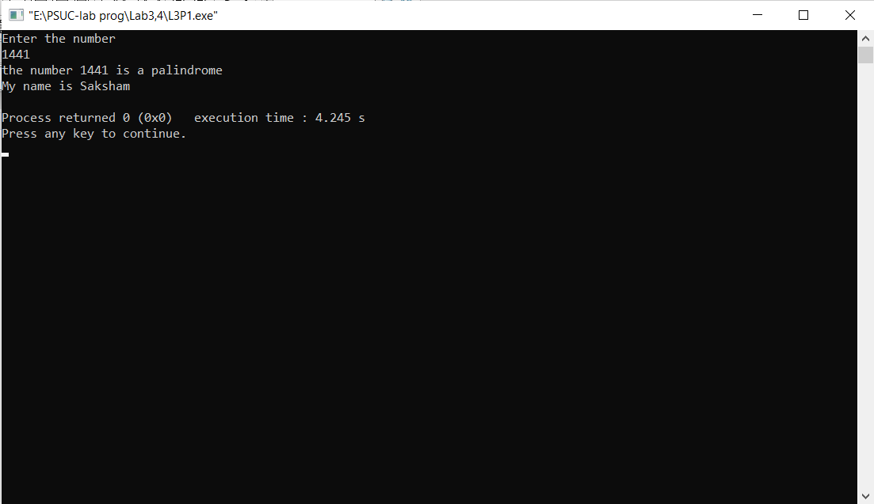}

**Output**:

**Q2**) Generate prime numbers between 2 given limits. (use while loop)

**Code**:

include<stdio.h>

int main()

{

int m,n;

int i,j,prime;

printf("Enter the limits\n");

scanf("%d%d",&m,&n);

i=m;

printf("The Prime numbers withing the limits are:\n");

while(i<n)

{

int prime=1,j=2;

while(j<i)

{

if(i%j==0)

{

prime=0;

break;

}

j++;

}

if (prime==1)

printf("%d\t",i);

i++;

}

printf("\nMy name is Saksham");

return 0;

}

**Output**:

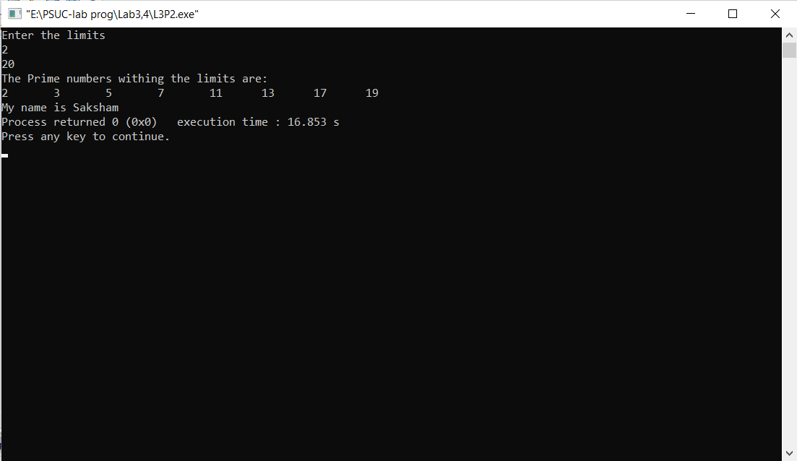

Q3) Check if the sum of the cubes of all digits of an inputted number equals the number itself (Armstrong Number). (use while loop)

Code:

#include<stdio.h>

int main()

{

int num, onum, r, result=0;

printf("Enter the number to check if an Armstrong number: \n");

scanf("%d", &onum);

num = onum;

while(num != 0)

{

r = num % 10;

result += r*r*r;

num /= 10;

}

if(result == onum)

printf("The given number %d is an Armstrong number.\n", onum);

else

printf("The given number %d is not an Armstrong number.\n", onum);

printf("My name is Saksham Mamtani");

}

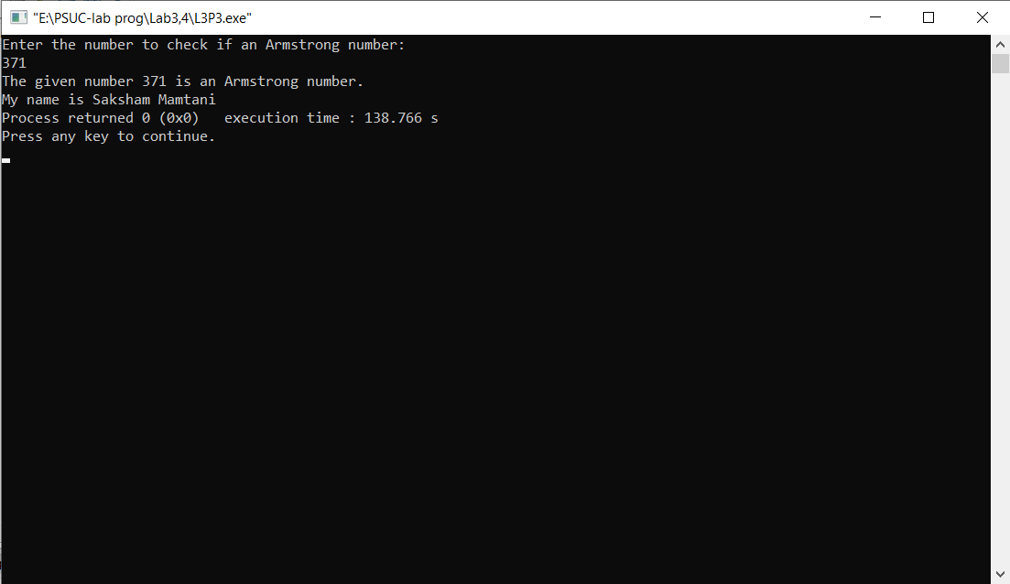**Output:**

**Q4**) Write a program using do-while loop to read the numbers until -1 is encountered. Also count the number of prime numbers and composite numbers entered by user.

**Code**:

#include<stdio.h>

int main()

{

int num,count=0,pc=0,cc=0;

int i=0;

do

{

count = 0;

printf("Enter a number\n");

scanf("%d",&num);

if(num>1)

{

i=1;

while(i<=num)

{

if(num%i==0)

count++;

i++;

}

if (count==2)

{

printf("%d is a prime number\n",num);

pc++;

}

else

{

printf("%d is not a prime number \n",num);

cc++;

}

}

}while(num!=-1);

printf("the number of prime numbers are %d\n ",pc);

printf("the number of composite numbers are %d\n",cc);

printf("My name is Saksham");

return 0;

}

**Output**:

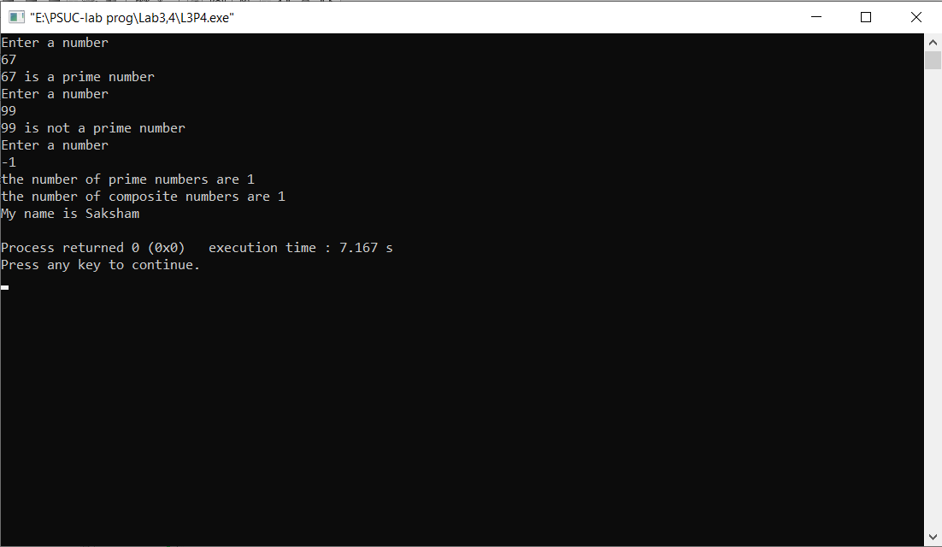

**Q5**) Check whether the given number is strong or not.

**Code**:

#include<stdio.h>

int main()

{

int num , copy , digit , sum,i;

printf("Enter the number\n");

scanf("%d",&num);

copy = num;

sum=0;

while (num>0)

{

digit = num%10;

i=1;

while(digit>=1)

{

i=i*digit;

digit--;

}

sum = sum+i;

num = num/10;

}

if (sum == copy)

printf ("%d is a strong number\n",copy);

else

printf("%d is not a strong number\n",copy);

printf("My name is Saksham");

return 0;

}

**Output :**

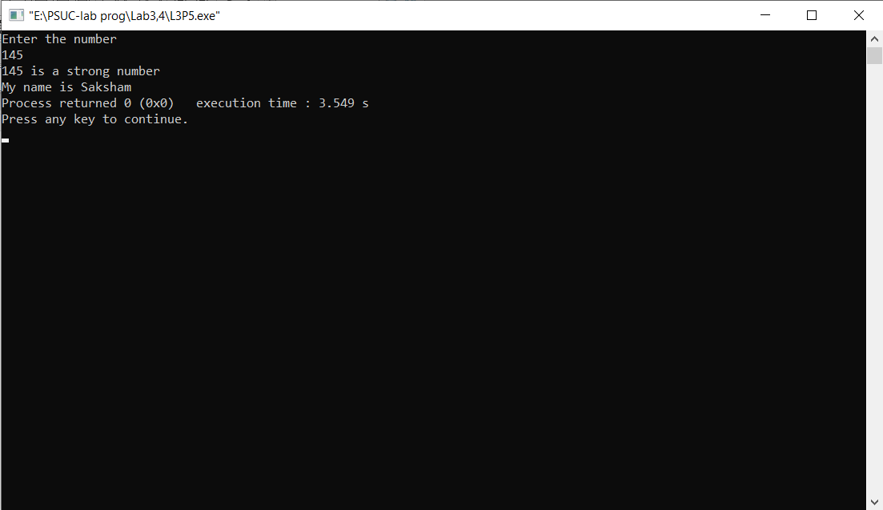

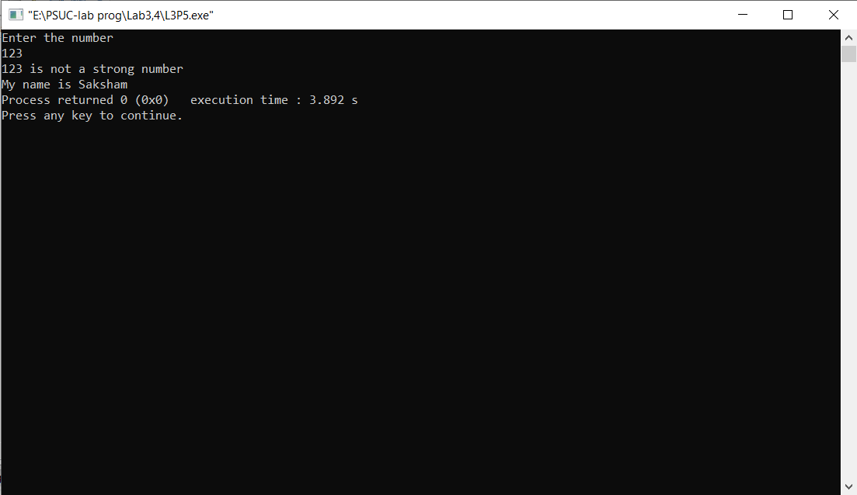

**Q6**) Write a program to demonstrate use of break and continue statements in while and do-while loops.

**Code:**

**a) using while loop**

#include <stdio.h>

int main()

{

int counter=10;

while (counter >=0)

{

if (counter==7)

{

counter--;

continue;

}

printf("%d ", counter);

counter--;

if (counter == 1)

break;

}

printf("\nMy name is Saksham");

return 0;

}

Output:

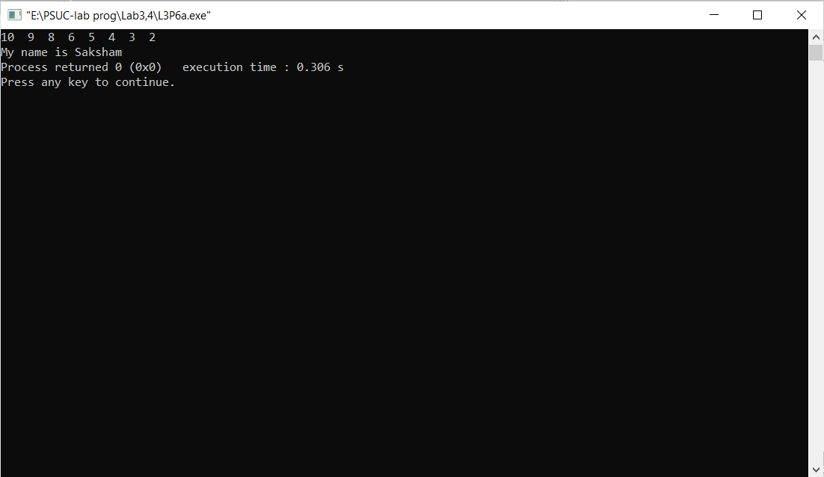

**b) with do while loop:**

#include <stdio.h>

int main()

{

int j=0;

do

{

if (j==4)

{

j++;

continue;

}

printf("%d ", j);

j++;

if (j==7)

break;

}while(j<10);

printf("\nMy name is Saksham");

return 0;

}

Output:

